OPERATING SYSTEMS AND SYSTEMS PROGRAMMING

2520030371 – P. HAVISHAA REDDY

PRACTICAL 6:

SERVER:

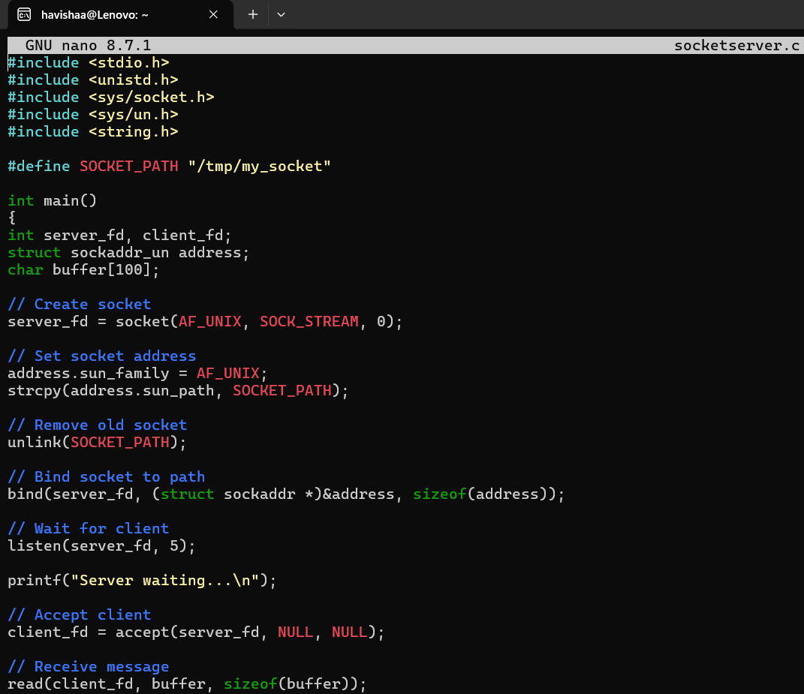
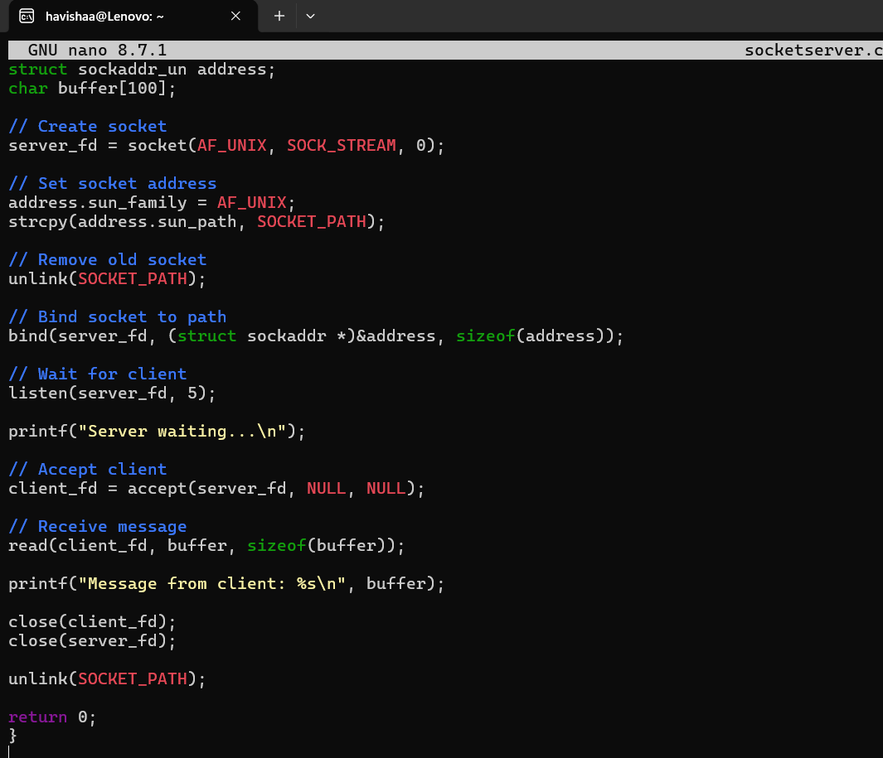

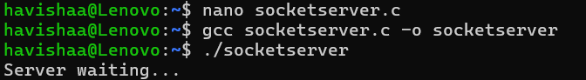

CLIENT:

